DAA-CSA0626

Lab programs

**192210595**

**1.Fibonacci series using recursion**

**Code:**

#include <stdio.h>

int fibo(int n) {

if (n == 0)

return 0;

else if (n == 1)

return 1;

else

return fibo(n - 1) + fibo(n - 2);

}

int main() {

int n, i;

printf("Enter size of series: ");

scanf("%d", &n);

printf("Fibonacci series of size %d is: ", n);

for (i = 0; i < n; i++) {

printf("%d ", fibo(i));

}

return 0;

}

**Output:**

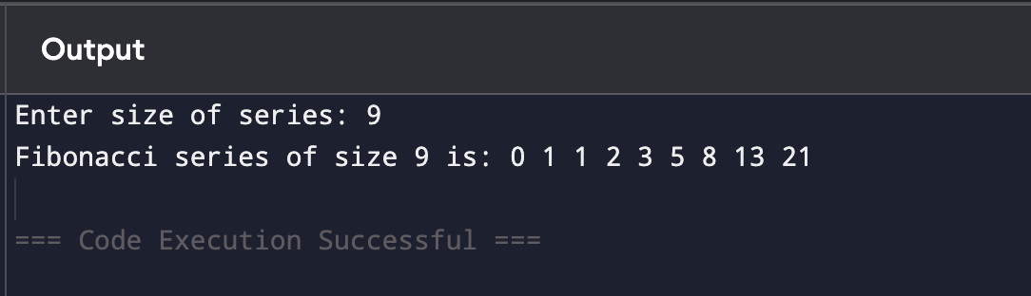

**2.Armstrong number**

**Code:**

#include <stdio.h>

int main() {

int n,temp,sum=0,rem;

printf("enter a number:");

scanf("%d",&n);

temp=n;

while(n!=0){

rem=n%10;

sum=sum+(rem*rem*rem);

n=n/10;

}

if(temp==sum){

printf("It is an armstrong number");

}

else{

printf("It is not an armstrong number");

}

}

**Output:**

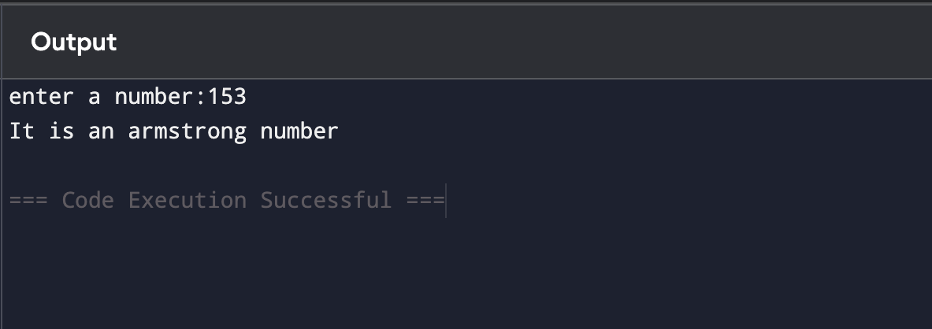

**3.GCD of numbers**

**Code:**

#include <stdio.h>

int main() {

int a, b, temp;

printf("Enter two numbers: ");

scanf("%d %d", &a, &b);

while (b != 0) {

temp = b;

b = a % b;

a = temp;

}

printf("The GCD of the given numbers is: %d", a);

return 0;

}

**Output:**

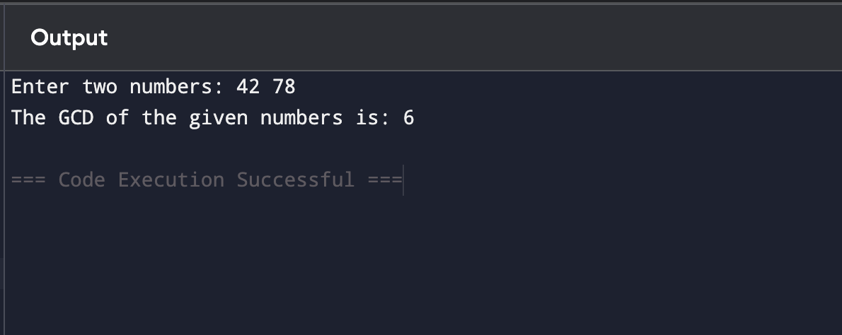

**4.Largest number in array**

**Code:**

#include <stdio.h>

int main() {

int n,i,max;

printf("Enter the size of the array: ");

scanf("%d",&n);

int arr[n];

printf("Enter %d elements: ", n);

for (i=0;i<n;i++) {

scanf("%d",&arr[i]);

}

max=arr[0];

for(i=1;i<n;i++){

if (arr[i]>max) {

max=arr[i];

}

}

printf("The largest number in the array is: %d", max);

return 0;

}

**Output:**

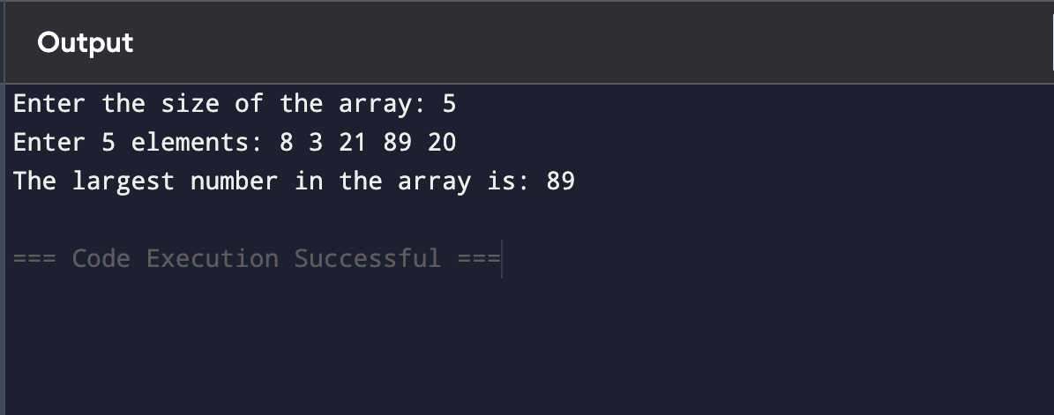

**5.Factorial of a number using recursion**

**Code:**

#include <stdio.h>

int factorial(int n) {

if (n==0||n==1)

return 1;

return n*factorial(n-1);

}

int main(){

int n;

printf("Enter a number: ");

scanf("%d",&n);

printf("The factorial of %d is: %d",n,factorial(n));

return 0;

}

**Output:**

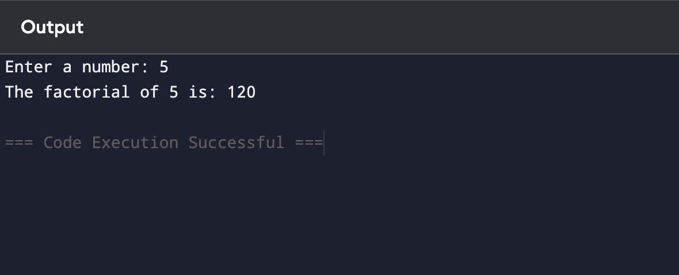

**6.Prime number**

**Code:**

#include <stdio.h>

int main() {

int n,i,isPrime = 1;

printf("Enter a number: ");

scanf("%d",&n);

if(n<=1)

isPrime=0;

for(i=2;i<=n/2; i++) {

if (n%i==0) {

isPrime=0;

break;

}

}

if(isPrime)

printf("%d is a prime number.", n);

else

printf("%d is not a prime number.", n);

return 0;

}

**Output:**

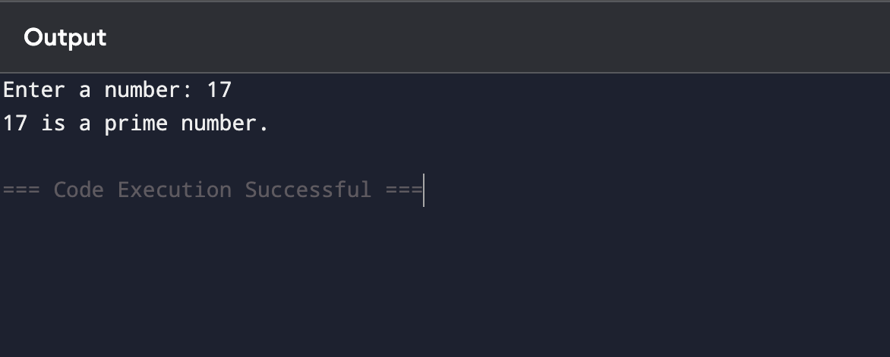

**7.Selection Sort**

**Code:**

#include <stdio.h>

int main() {

int n,i,j,temp;

printf("Enter the size of the array: ");

scanf("%d",&n);

int arr[n];

printf("Enter %d elements: ",n);

for(i=0;i<n;i++){

scanf("%d",&arr[i]);

}

for (i=0;i<n-1;i++) {

for (j=i+1;j<n;j++) {

if(arr[j]<arr[i]) {

temp=arr[i];

arr[i]=arr[j];

arr[j]=temp;

}

}

}

printf("Sorted array:");

for (i=0;i<n;i++) {

printf("%d ",arr[i]);

}

return 0;

}

**Output:**

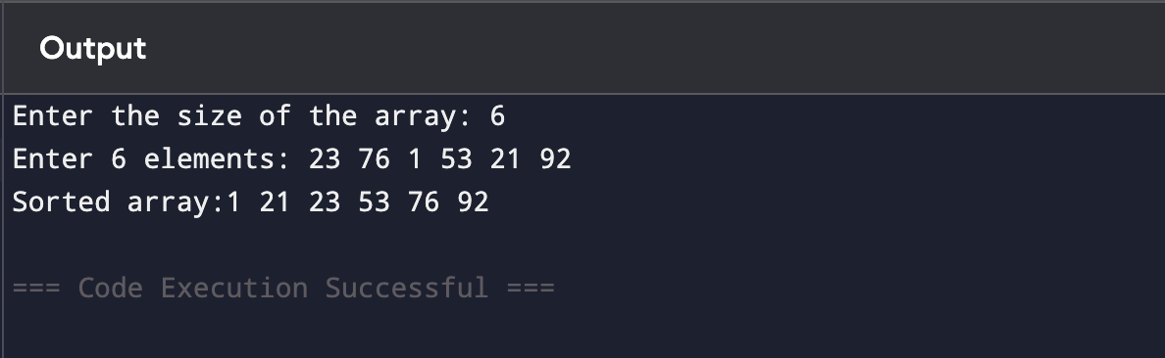

**8.Bubble Sort**

**Code:**

#include <stdio.h>

int main() {

int n,i,j,k,temp;

printf("Enter the number of elements: ");

scanf("%d",&n);

int arr[n];

printf("Enter %d elements:\n", n);

for(i=0;i<n;i++){

scanf("%d",&arr[i]);

}

for(i=0;i<n-1;i++){

for(j=0;j<n-i-1;j++){

if (arr[j]>arr[j+1]){

temp=arr[j];

arr[j]=arr[j+1];

arr[j+1]=temp;

}

}

printf("After pass %d: ", i+1);

for (k=0;k<n;k++) {

printf("%d ",arr[k]);

}

printf("\n");

}

printf("\nSorted array:\n");

for (i=0;i<n;i++) {

printf("%d ",arr[i]);

}

return 0;

}

***Output:***

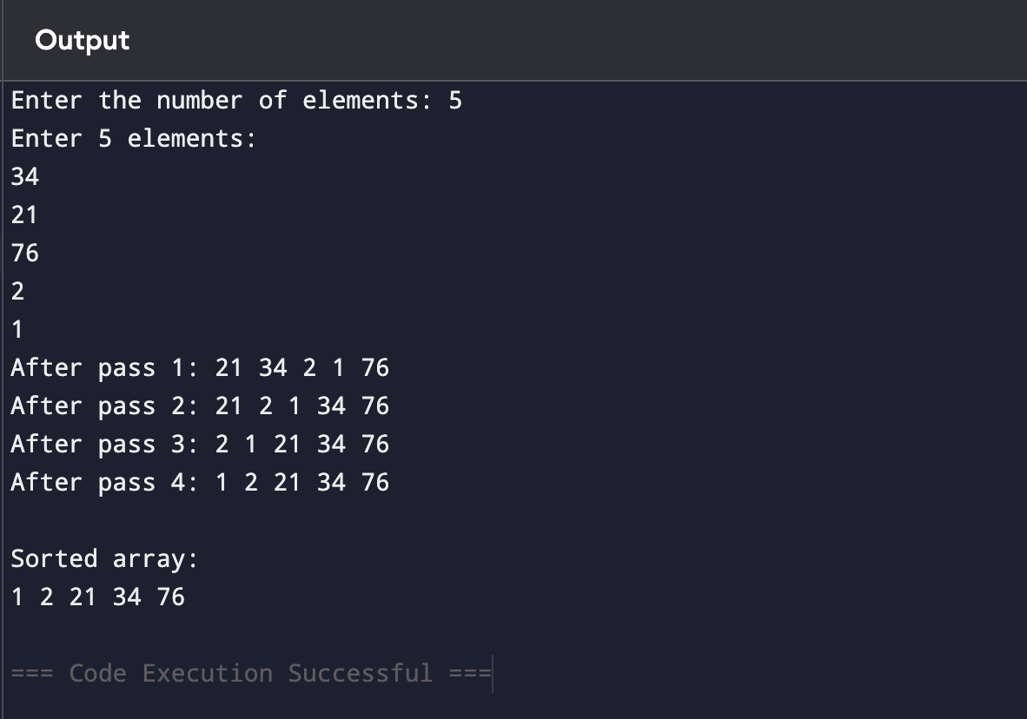

**9.Matrix Multiplication**

**Code:**

#include<stdio.h>

int main(){

int a[10][10],b[10][10],result[10][10],r1,c1,r2,c2,i,j,k;

printf("Enter no.of rows and columns for the first matrix: ");

scanf("%d%d",&r1,&c1);

printf("Enter no.of rows and columns for the second matrix: ");

scanf("%d%d",&r2,&c2);

if(c1!=r2){

printf("Matrix multiplication not possible.\n");

return 0;

}

printf("Enter elements of the first matrix:\n");

for(i=0;i<r1;i++){

for(j=0;j<c1;j++){

scanf("%d",&a[i][j]);

}

}

printf("Enter elements of the second matrix:\n");

for(i=0;i<r2;i++){

for(j=0;j<c2;j++){

scanf("%d",&b[i][j]);

}

}

for(i=0;i<r1;i++){

for(j=0;j<c2;j++){

result[i][j]=0;

for(k=0;k<c1;k++){

result[i][j]+=a[i][k]*b[k][j];

}

}

}

printf("Resultant matrix:\n");

for(i=0;i<r1;i++){

for(j=0;j<c2;j++){

printf("%d ",result[i][j]);

}

printf("\n");

}

return 0;

}

**Output:**

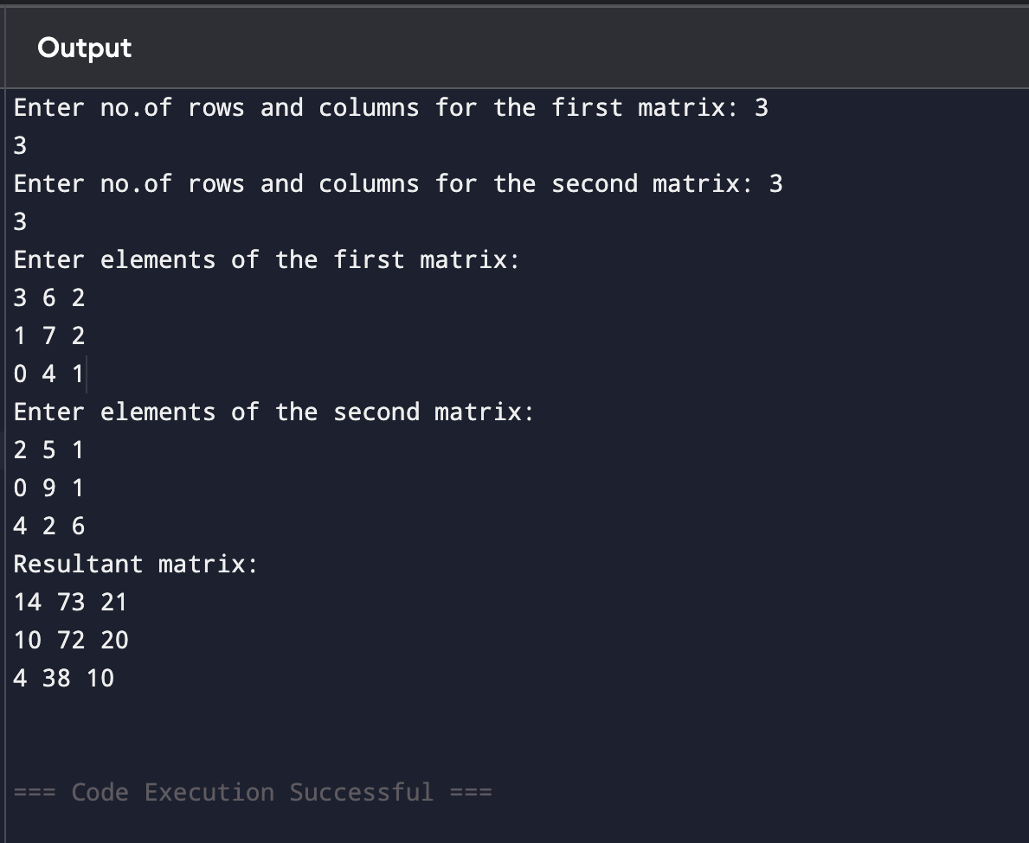

**10.String Palindrome**

**Code:**

#include<stdio.h>

#include<string.h>

int main(){

char str[100];

int i,len,flag=1;

printf("Enter a string: ");

scanf("%s",str);

len=strlen(str);

for(i=0;i<len/2;i++){

if(str[i]!=str[len-i-1]){

flag=0;

break;

}

}

if(flag){

printf("The string is a palindrome.\n");

}

else{

printf("The string is not a palindrome.\n");

}

return 0;

}

**Output:**

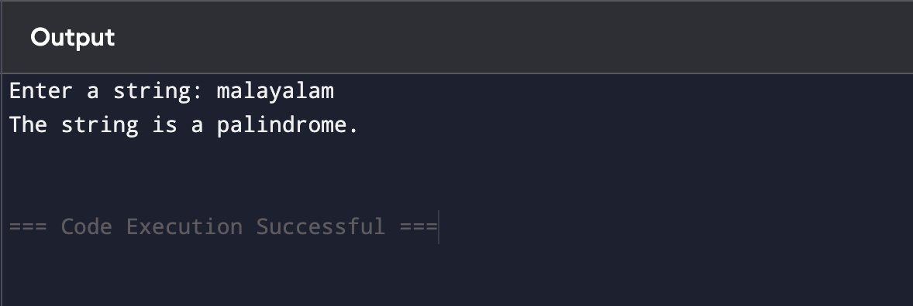

**11.String Copy**

**Code:**

#include<stdio.h>

int main(){

char str1[100],str2[100];

int i;

printf("Enter a string: ");

scanf("%s",str1);

for(i=0;str1[i]!='\0';i++){

str2[i]=str1[i];

}

str2[i]='\0';

printf("Original string: %s\n",str1);

printf("Copied string: %s\n",str2);

return 0;

}

**Output:**

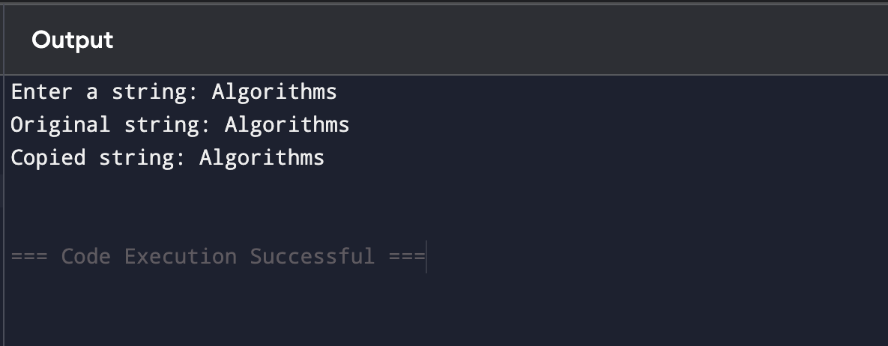

**12.Binary Search**

**Code:**

#include<stdio.h>

int main(){

int arr[100],n,i,j,temp,key,low,high,mid;

printf("Enter the number of elements: ");

scanf("%d",&n);

printf("Enter %d elements:\n",n);

for(i=0;i<n;i++){

scanf("%d",&arr[i]);

}

for(i=0;i<n;i++){

for(j=i+1;j<n;j++){

if(arr[i]>arr[j]){

temp=arr[i];

arr[i]=arr[j+1];

arr[j+1]=temp;

}

}

}

printf("Sorted array: ");

for(i=0;i<n;i++){

printf("%d ",arr[i]);

}

printf("\n");

printf("Enter the element to search: ");

scanf("%d",&key);

low=0;

high=n-1;

while(low<=high){

mid=(low+high)/2;

if(arr[mid]==key){

printf("Element found at index %d.\n",mid);

return 0;

}

else if(arr[mid]<key){

low=mid+1;

}

else{

high=mid-1;

}

}

printf("Element not found.\n");

return 0;

}

**Output:**

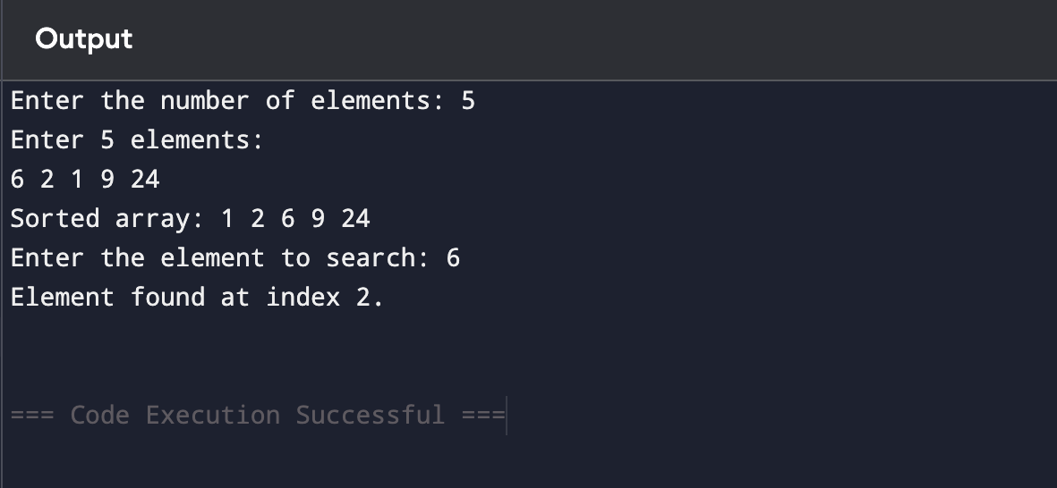

**13.String Reverse**

**Code:**

#include<stdio.h>

int main(){

char str[100],rev[100];

int i,len=0;

printf("Enter a string: ");

scanf("%s",str);

while(str[len]!='\0'){

len++;

}

for(i=0;i<len;i++){

rev[i]=str[len-i-1];

}

rev[len]='\0';

printf("Reversed string: %s\n",rev);

return 0;

}

**Output:**

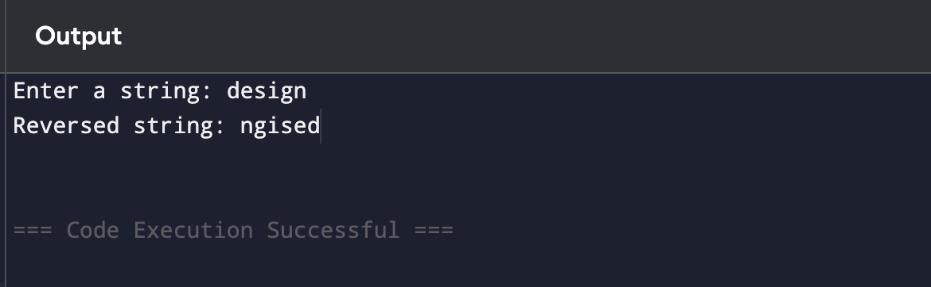

**14.Length of String**

**Code:**

#include<stdio.h>

int main(){

char str[100];

int i,length=0;

printf("Enter a string: ");

scanf("%s",str);

for(i=0;str[i]!='\0';i++){

length++;

}

printf("Length of the string: %d\n",length);

return 0;

}

**Output:**

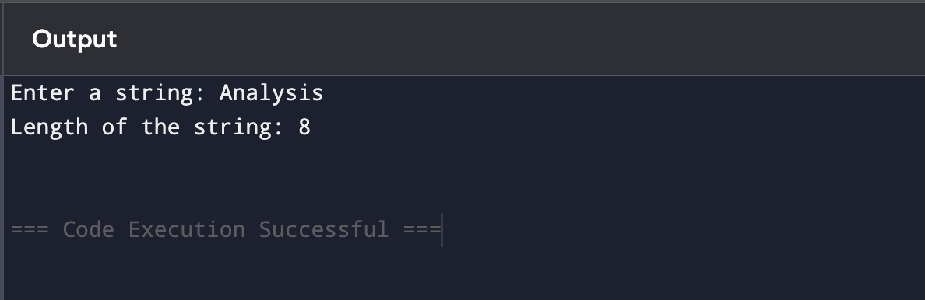

**15.Strassen's Matrix Multiplication**

**Code:**

#include<stdio.h>

void st(int A[2][2], int B[2][2], int C[2][2]) {

int P,Q,R,S,T,U,V;

P=(A[0][0]+A[1][1])*(B[0][0]+B[1][1]);

Q=(A[1][0]+A[1][1])*B[0][0];

R=A[0][0]*(B[0][1]-B[1][1]);

S=A[1][1]*(B[1][0]-B[0][0]);

T=(A[0][0]+A[0][1])*B[1][1];

U=(A[1][0]-A[0][0])*(B[0][0]+B[0][1]);

V=(A[0][1]-A[1][1])*(B[1][0]+B[1][1]);

C[0][0]=P+S-T+V;

C[0][1]=R+T;

C[1][0]=Q+S;

C[1][1]=P+R-Q+U;

}

int main() {

int A[2][2],B[2][2],C[2][2];

printf("Enter elements of the first matrix\n");

for (int i=0;i<2;i++) {

for (int j=0;j<2;j++) {

scanf("%d",&A[i][j]);

}

}

printf("Enter elements of the second matrix\n");

for (int i=0;i<2;i++) {

for (int j=0;j<2;j++) {

scanf("%d",&B[i][j]);

}

}

st(A,B,C);

printf("Resultant matrix:\n");

for(int i=0;i<2;i++){

for(int j=0;j<2;j++){

printf("%d ", C[i][j]);

}

printf("\n");

}

return 0;

}

**Output:**

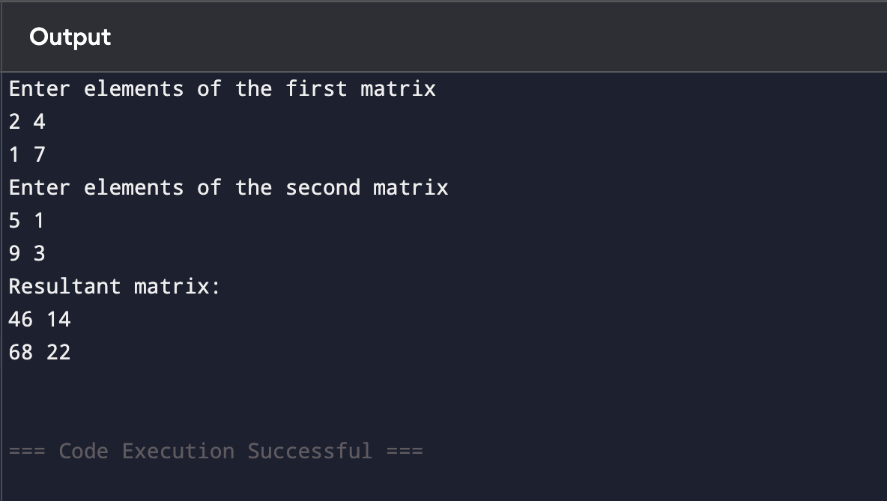

**16.MERGE SORT**

**CODE:**

#include<stdio.h>

int main(){

int n;

printf("Enter number of elements:");

scanf("%d",&n);

int arr[n],temp[n];

printf("Enter elements:");

for(int i=0;i<n;i++)scanf("%d",&arr[i]);

for(int size=1;size<n;size*=2){

for(int left=0;left<n-1;left+=2*size){

int mid=left+size-1;

int right=(left+2*size-1<n-1)?left+2*size-1:n-1;

int i=left,j=mid+1,k=left;

while(i<=mid&&j<=right){

if(arr[i]<=arr[j])temp[k++]=arr[i++];

else temp[k++]=arr[j++];

}

while(i<=mid)temp[k++]=arr[i++];

while(j<=right)temp[k++]=arr[j++];

}

for(int i=0;i<n;i++)arr[i]=temp[i];

}

printf("Sorted array:");

for(int i=0;i<n;i++)printf("%d ",arr[i]);

return 0;

}

**OUTPUT:**

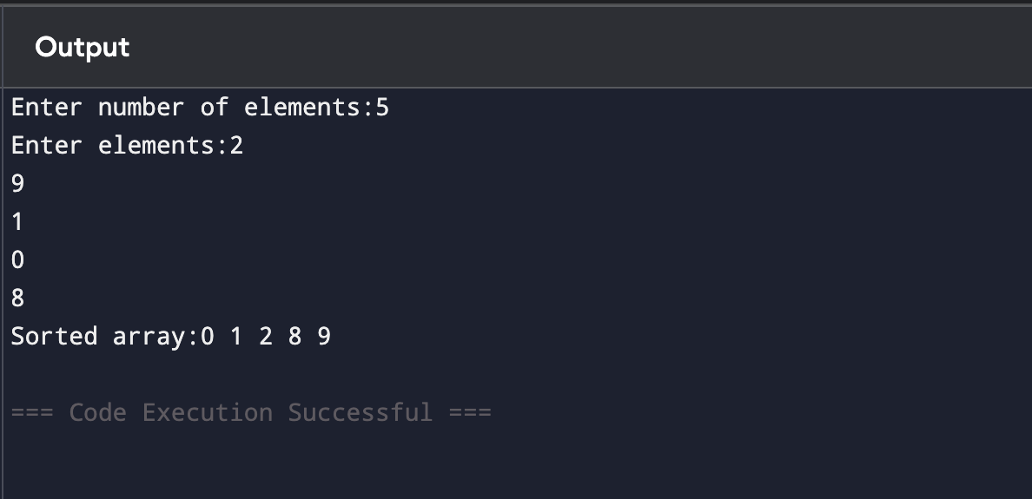

**17.MIN and MAX**

**CODE:**

#include<stdio.h>

int main(){

int n;

printf("Enter the number of elements:");

scanf("%d",&n);

int arr[n];

printf("Enter the elements:");

for(int i=0;i<n;i++)scanf("%d",&arr[i]);

int max,min,mid,low=0,high=n-1,max1,min1,max2,min2;

while(low<high){

mid=(low+high)/2;

max1=arr[low],min1=arr[low];

for(int i=low;i<=mid;i++){

if(arr[i]>max1)max1=arr[i];

if(arr[i]<min1)min1=arr[i];

}

max2=arr[mid+1],min2=arr[mid+1];

for(int i=mid+1;i<=high;i++){

if(arr[i]>max2)max2=arr[i];

if(arr[i]<min2)min2=arr[i];

}

max=(max1>max2)?max1:max2;

min=(min1<min2)?min1:min2;

break;

}

printf("Maximum value:%d\n",max);

printf("Minimum value:%d\n",min);

return 0;

}

**OUTPUT:**

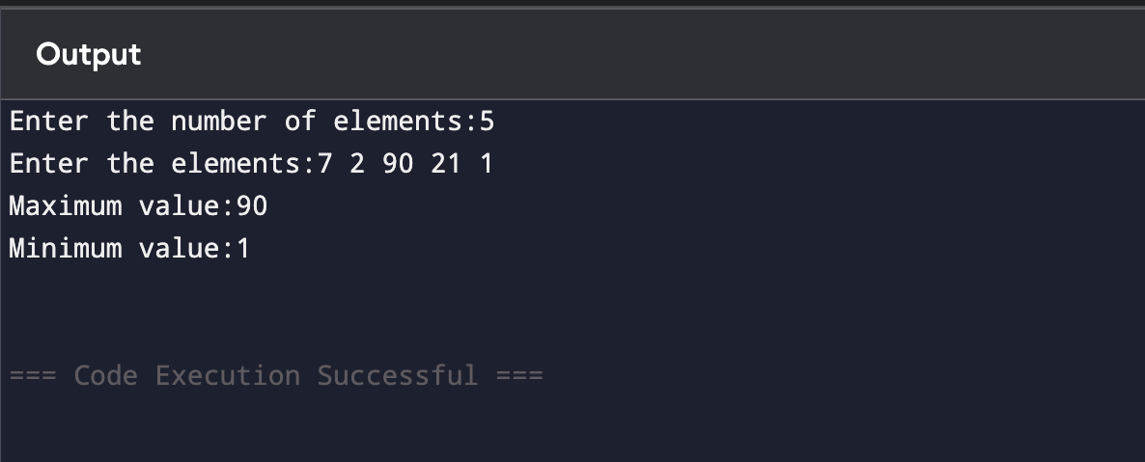

**19.Knapsack using Greedy method**

**CODE:**

#include<stdio.h>

int main(){

int n;

printf("Enter the number of items:");

scanf("%d",&n);

int weight[n],value[n],i,j;

float ratio[n],temp;

printf("Enter weights of items:");

for(i=0;i<n;i++)scanf("%d",&weight[i]);

printf("Enter values of items:");

for(i=0;i<n;i++)scanf("%d",&value[i]);

for(i=0;i<n;i++)ratio[i]=(float)value[i]/weight[i];

for(i=0;i<n-1;i++){

for(j=0;j<n-i-1;j++){

if(ratio[j]<ratio[j+1]){

temp=ratio[j],ratio[j]=ratio[j+1],ratio[j+1]=temp;

temp=weight[j],weight[j]=weight[j+1],weight[j+1]=temp;

temp=value[j],value[j]=value[j+1],value[j+1]=temp;

}

}

}

int capacity;

printf("Enter knapsack capacity:");

scanf("%d",&capacity);

float totalValue=0.0;

for(i=0;i<n&&capacity>0;i++){

if(weight[i]<=capacity){

totalValue+=value[i];

capacity-=weight[i];

}else{

totalValue+=capacity*ratio[i];

capacity=0;

}

}

printf("Maximum value in Knapsack:%.2f\n",totalValue);

return 0;

}

**OUTPUT:**

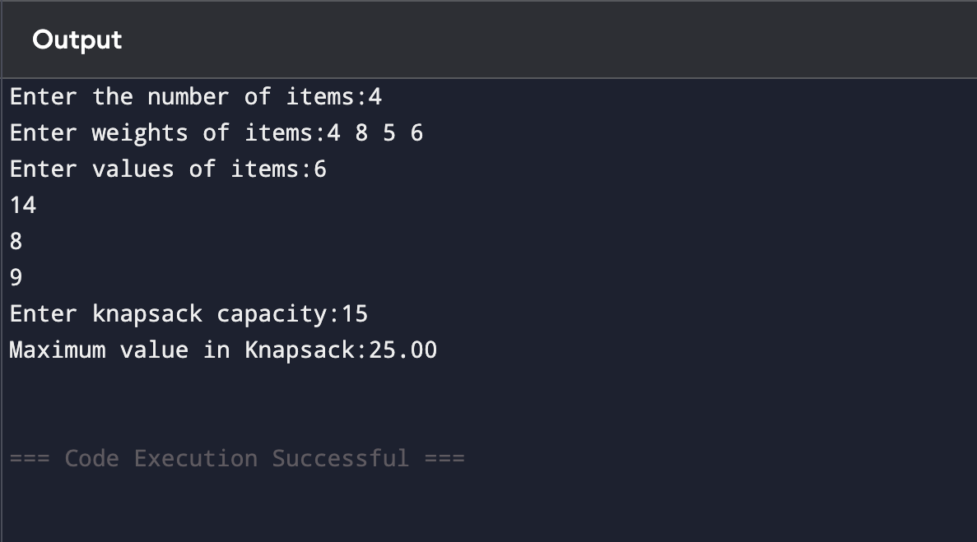

**20.MST using Greedy Technique**

**CODE:**

#include<stdio.h>

int main(){

int n,e;

printf("Enter the number of vertices:");

scanf("%d",&n);

printf("Enter the number of edges:");

scanf("%d",&e);

int edges[e][3],i,j,parent[n],u,v;

printf("Enter edges (u v weight):");

for(i=0;i<e;i++)scanf("%d%d%d",&edges[i][0],&edges[i][1],&edges[i][2]);

for(i=0;i<e-1;i++){

for(j=0;j<e-i-1;j++){

if(edges[j][2]>edges[j+1][2]){

int temp0=edges[j][0],temp1=edges[j][1],temp2=edges[j][2];

edges[j][0]=edges[j+1][0];

edges[j][1]=edges[j+1][1];

edges[j][2]=edges[j+1][2];

edges[j+1][0]=temp0;

edges[j+1][1]=temp1;

edges[j+1][2]=temp2;

}

}

}

for(i=0;i<n;i++)parent[i]=i;

int find(int v){

while(parent[v]!=v)v=parent[v];

return v;

}

void unionSets(int u,int v){

parent[find(u)]=find(v);

}

int mstWeight=0;

printf("Edges in MST:\n");

for(i=0;i<e;i++){

u=edges[i][0];

v=edges[i][1];

if(find(u)!=find(v)){

printf("%d-%d (%d)\n",u,v,edges[i][2]);

mstWeight+=edges[i][2];

unionSets(u,v);

}

}

printf("Total weight of MST:%d\n",mstWeight);

return 0;

}

**OUTPUT:**

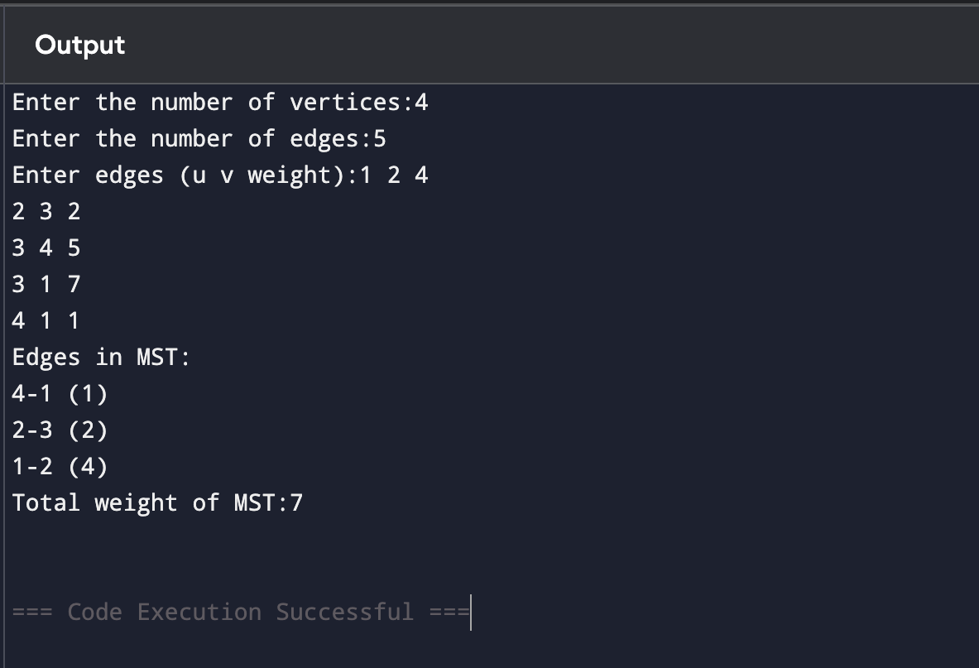

**21.Optimal Binary Search Tree using Dynamic Programming**

**CODE:**

#include<stdio.h>

int main(){

int n;

printf("Enter the number of keys:");

scanf("%d",&n);

int keys[n+1],freq[n+1];

printf("Enter keys in sorted order:");

for(int i=1;i<=n;i++)scanf("%d",&keys[i]);

printf("Enter frequencies of keys:");

for(int i=1;i<=n;i++)scanf("%d",&freq[i]);

int cost[n+1][n+1],sum[n+1][n+1];

for(int i=1;i<=n;i++){

cost[i][i]=freq[i];

sum[i][i]=freq[i];

}

for(int l=2;l<=n;l++){

for(int i=1;i<=n-l+1;i++){

int j=i+l-1;

sum[i][j]=sum[i][j-1]+freq[j];

cost[i][j]=999999; // Representing infinity

for(int r=i;r<=j;r++){

int c=(r>i?cost[i][r-1]:0)+(r<j?cost[r+1][j]:0)+sum[i][j];

if(c<cost[i][j])cost[i][j]=c;

}

}

}

printf("Optimal cost of Binary Search Tree:%d\n",cost[1][n]);

return 0;

}

**OUTPUT:**

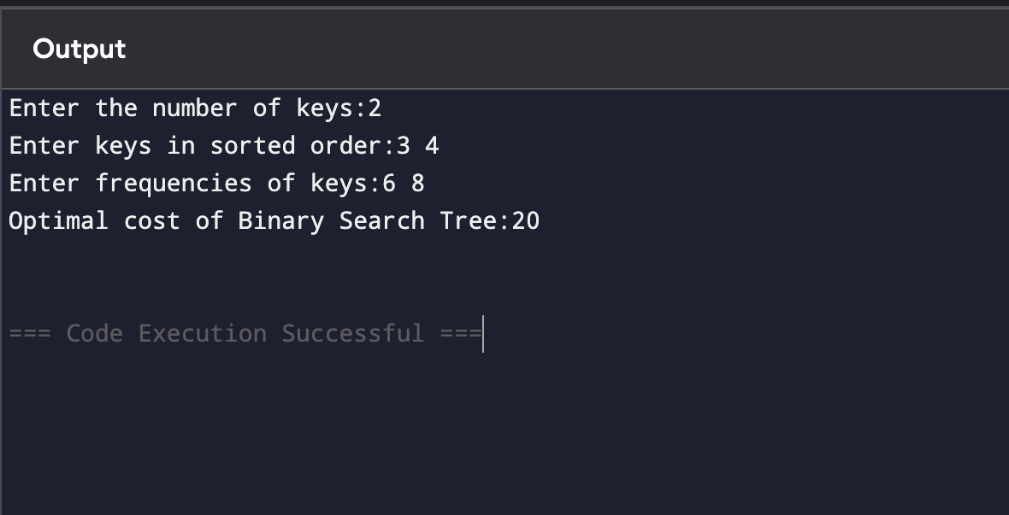

**22.Binary Coefficient using Dynamic Programming**

**CODE:**

#include<stdio.h>

int main(){

int n,k;

printf("Enter n and k:");

scanf("%d%d",&n,&k);

int C[n+1][k+1];

for(int i=0;i<=n;i++){

for(int j=0;j<=k;j++){

if(j==0||j==i)C[i][j]=1;

else C[i][j]=C[i-1][j-1]+C[i-1][j];

}

}

printf("Binomial Coefficient C(%d,%d):%d\n",n,k,C[n][k]);

return 0;

}

**OUTPUT:**

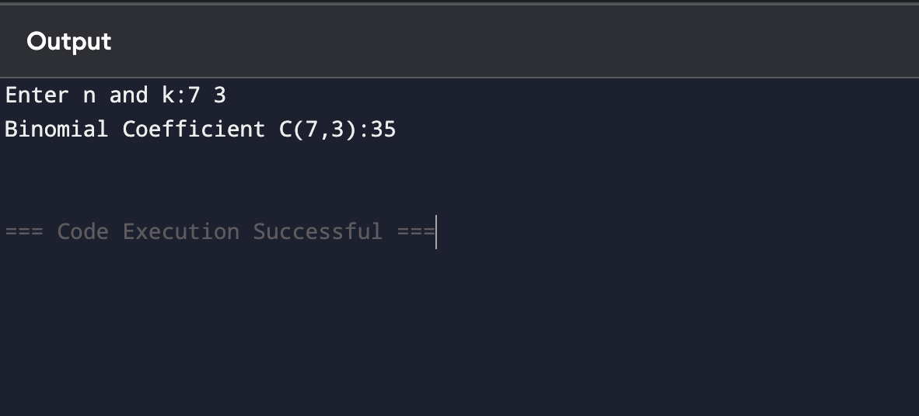

**25.TSP using Dynamic Programming**

**CODE:**

#include<stdio.h>

#define INF 999999

int main(){

int n;

printf("Enter the number of cities: ");

scanf("%d",&n);

int cost[n][n];

printf("Enter the cost matrix:\n");

for(int i=0;i<n;i++){

for(int j=0;j<n;j++){

scanf("%d",&cost[i][j]);

}

}

int dp[1<<n][n];

for(int mask=0;mask<(1<<n);mask++){

for(int i=0;i<n;i++)dp[mask][i]=INF;

}

dp[1][0]=0; // Starting city is 0

for(int mask=1;mask<(1<<n);mask++){

for(int i=0;i<n;i++){

if(!(mask&(1<<i)))continue;

for(int j=0;j<n;j++){

if(mask&(1<<j))continue;

dp[mask|(1<<j)][j]=dp[mask|(1<<j)][j]<dp[mask][i]+cost[i][j]?dp[mask|(1<<j)][j]:dp[mask][i]+cost[i][j];

}

}

}

int res=INF;

for(int i=1;i<n;i++)res=res<dp[(1<<n)-1][i]+cost[i][0]?res:dp[(1<<n)-1][i]+cost[i][0];

printf("The minimum cost of the tour is: %d\n",res);

return 0;

}

**OUTPUT:**

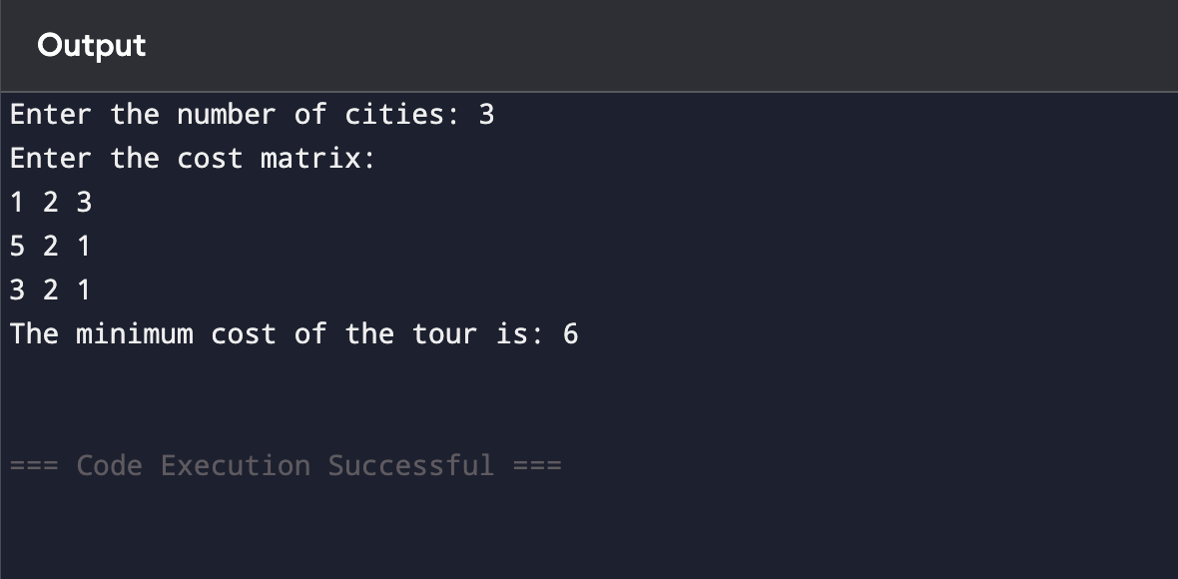

**31.MIN and Max Sequence for all numbers list**

**CODE:**

#include<stdio.h>

int main(){

int n;

printf("Enter the number of elements in the list: ");

scanf("%d", &n);

int arr[n];

printf("Enter the elements of the list: ");

for(int i = 0; i < n; i++) {

scanf("%d", &arr[i]);

}

printf("Minimum value sequence:\n");

for(int i = 0; i < n; i++) {

int min = arr[i];

for(int j = i; j < n; j++) {

if(arr[j] < min) {

min = arr[j];

}

printf("%d ", min);

}

printf("\n");

}

printf("Maximum value sequence:\n");

for(int i = 0; i < n; i++) {

int max = arr[i];

for(int j = i; j < n; j++) {

if(arr[j] > max) {

max = arr[j];

}

printf("%d ", max);

}

printf("\n");

}

return 0;

}

**OUTPUT:**

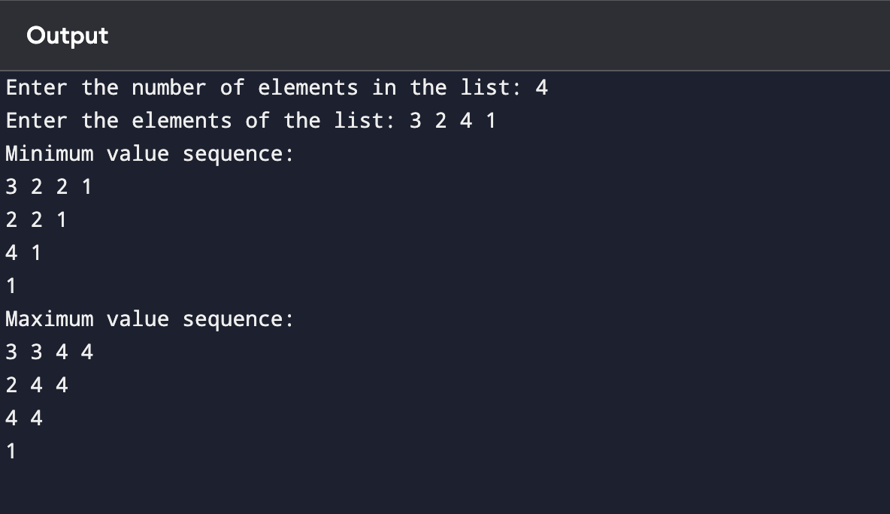

**32.N Queens using Backtracking technique**

**CODE:**

#include<stdio.h>

#define MAX 10

int board[MAX][MAX];

int isSafe(int row,int col,int n){

for(int i=0;i<col;i++){

if(board[row][i])return 0;

}

for(int i=row,j=col;i>=0&&j>=0;i--,j--){

if(board[i][j])return 0;

}

for(int i=row,j=col;i<n&&j>=0;i++,j--){

if(board[i][j])return 0;

}

return 1;

}

int solveNQueens(int col,int n){

if(col>=n)return 1;

for(int i=0;i<n;i++){

if(isSafe(i,col,n)){

board[i][col]=1;

if(solveNQueens(col+1,n))return 1;

board[i][col]=0;

}

}

return 0;

}

int main(){

int n;

printf("Enter the value of N: ");

scanf("%d",&n);

for(int i=0;i<n;i++){

for(int j=0;j<n;j++)board[i][j]=0;

}

if(solveNQueens(0,n)){

printf("Solution for %d Queens problem:\n",n);

for(int i=0;i<n;i++){

for(int j=0;j<n;j++){

if(board[i][j])printf("Q ");

else printf(". ");

}

printf("\n");

}

}else{

printf("No solution exists for %d Queens problem.\n",n);

}

return 0;

}

**OUTPUT:**

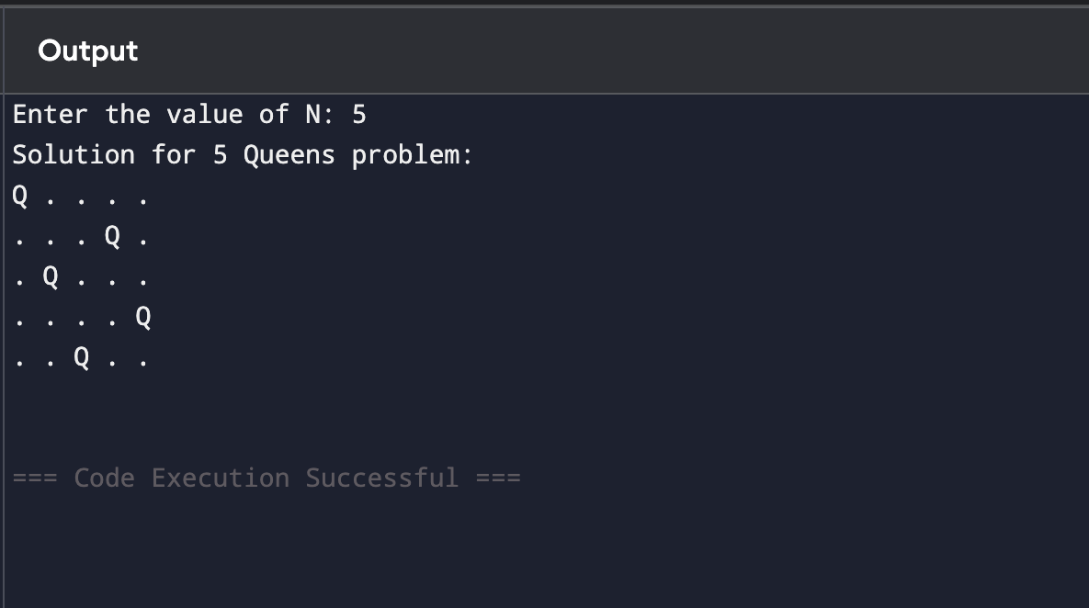

**34.Sum of Subsets using Backtracking Technique**

**CODE:**

#include<stdio.h>

int n, target, found = 0;

void sumOfSubsets(int arr[], int subset[], int idx, int curr_sum, int start) {

if(curr_sum == target) {

found = 1;

printf("Subset: ");

for(int i = 0; i < idx; i++) {

printf("%d ", subset[i]);

}

printf("\n");

return;

}

for(int i = start; i < n; i++) {

if(curr_sum + arr[i] <= target) {

subset[idx] = arr[i];

sumOfSubsets(arr, subset, idx + 1, curr_sum + arr[i], i + 1);

}

}

}

int main() {

printf("Enter the number of elements in the set: ");

scanf("%d", &n);

int arr[n], subset[n];

printf("Enter the elements of the set: ");

for(int i = 0; i < n; i++) {

scanf("%d", &arr[i]);

}

printf("Enter the target sum: ");

scanf("%d", &target);

printf("Subsets with sum %d:\n", target);

sumOfSubsets(arr, subset, 0, 0, 0);

if(!found) {

printf("No subsets found with the given sum.\n");

}

return 0;

}

**OUTPUT:**

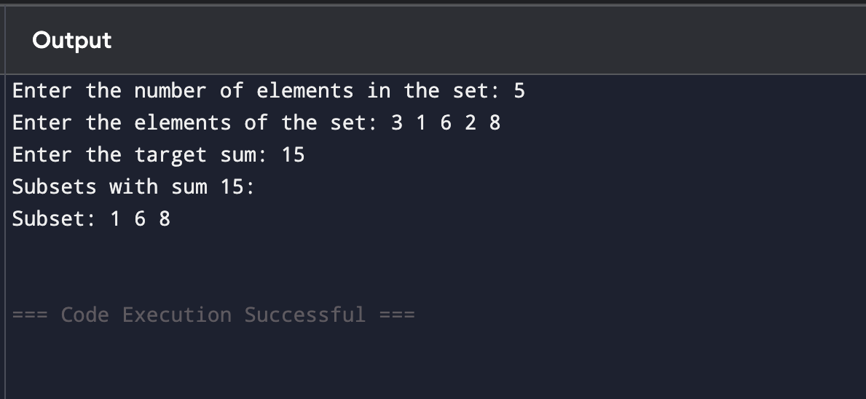

**35.Graph Coloring using Backtracking**

**CODE:**

#include<stdio.h>

#define MAX 10

int n, graph[MAX][MAX], colors[MAX], m;

int isSafe(int node, int c) {

for (int i = 0; i < n; i++) {

if (graph[node][i] && colors[i] == c) return 0;

}

return 1;

}

int graphColoring(int node) {

if (node == n) return 1;

for (int c = 1; c <= m; c++) {

if (isSafe(node, c)) {

colors[node] = c;

if (graphColoring(node + 1)) return 1;

colors[node] = 0;

}

}

return 0;

}

int main() {

printf("Enter the number of vertices in the graph: ");

scanf("%d", &n);

printf("Enter the adjacency matrix of the graph:\n");

for (int i = 0; i < n; i++) {

for (int j = 0; j < n; j++) {

scanf("%d", &graph[i][j]);

}

}

printf("Enter the number of colors: ");

scanf("%d", &m);

for (int i = 0; i < n; i++) colors[i] = 0;

if (graphColoring(0)) {

printf("Solution exists with the following coloring:\n");

for (int i = 0; i < n; i++) {

printf("Vertex %d: Color %d\n", i + 1, colors[i]);

}

} else {

printf("No solution exists with the given number of colors.\n");

}

return 0;

}

**OUTPUT:**

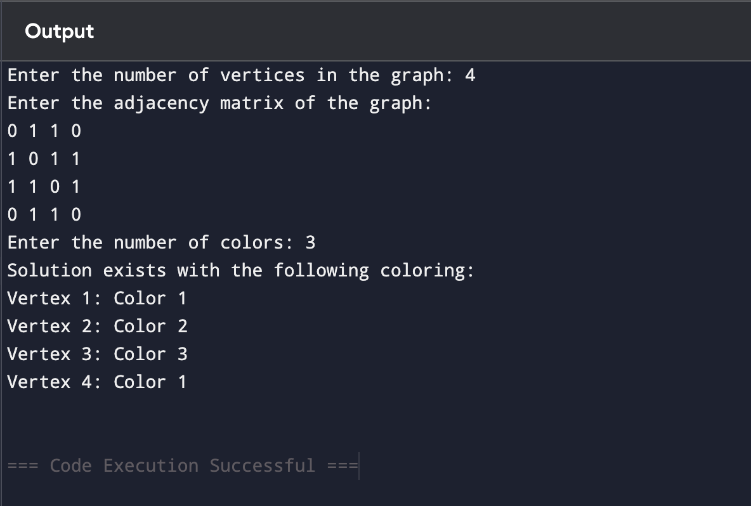

**40.Hamiltonian Circuit using Backtracking**

**CODE:**

#include<stdio.h>

#define MAX 10

int n,graph[MAX][MAX],path[MAX];

int main(){

int isSafe(int v,int pos){

if(graph[path[pos-1]][v]==0)return 0;

for(int i=0;i<pos;i++){

if(path[i]==v)return 0;

}

return 1;

}

int hamiltonian(int pos){

if(pos==n)return graph[path[pos-1]][path[0]]==1;

for(int v=1;v<n;v++){

if(isSafe(v,pos)){

path[pos]=v;

if(hamiltonian(pos+1))return 1;

path[pos]=-1;

}

}

return 0;

}

printf("Enter the number of vertices: ");

scanf("%d",&n);

printf("Enter the adjacency matrix:\n");

for(int i=0;i<n;i++){

for(int j=0;j<n;j++){

scanf("%d",&graph[i][j]);

}

}

for(int i=0;i<n;i++)path[i]=-1;

path[0]=0;

if(hamiltonian(1)){

printf("Hamiltonian Circuit exists: ");

for(int i=0;i<n;i++)printf("%d ",path[i]);

printf("%d\n",path[0]);

}

else{

printf("No Hamiltonian Circuit exists.\n");

}

return 0;

}

**OUTPUT:**

